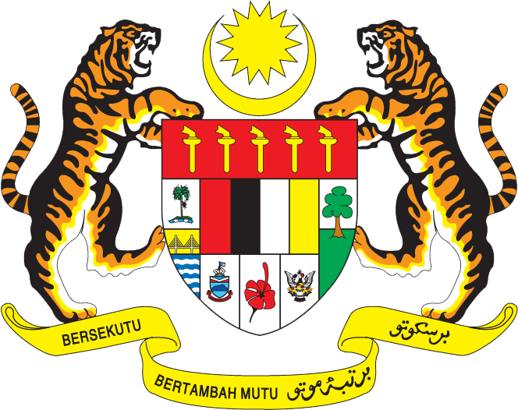

Statement by H.E. Ambassador Amran Mohamed Zin
Permanent Representative of Malaysia to the United Nations Office and Other International Organizations in Geneva
27th Session of the UPR Working Group: Review of the Republic of Indonesia
3 May 2017

Mr. President,

My delegation welcomes Her Excellency Minister Retno Marsudi, Minister of Foreign Affairs, and the Indonesian delegation. We congratulate Indonesia for the presentation of its UPR national report.

- Malaysia commends the advancement made by Indonesia in the promotion and protection of human rights. We welcome Indonesia’s ratification of the two CRC Optional Protocols and significant progress in advancing the rights of women. Malaysia also recognizes Indonesia’s important contribution to pursuing ASEAN common human rights agenda in our region.

- In the spirit of constructively contributing to Indonesia’s Review, my delegation recommends the following for Indonesia’s consideration:

  - One: Continue with the efforts to strengthen access to justice for juveniles in conflict with the law, and share best practices with the wider region;

  - Two: Step up the efforts to combat violence and crimes against children, including sexual offences, sale of children, child prostitution and child pornography.

- We wish Indonesia the best with its undertakings to further the progress in the field of human rights.

Thank you.

GENEVA
3 May 2017

